I
n this session we will try to understand what is decision table with HIT policy Collect

HIT Policy Collect is multiple HIT policy.

COLLECT: Multiple rules can be satisfied. The decision table result contains the output of all satisfied rules in an arbitrary order as a list.

Camunda DMN Decision Table HIT policy Collection

- + (sum): the result of the decision table is the sum of all the distinct outputs.
- < (min): the result of the decision table is the smallest value of all the outputs.
- > (max): the result of the decision table is the largest value of all the outputs.
- # (count): the result of the decision table is the number of distinct outputs.

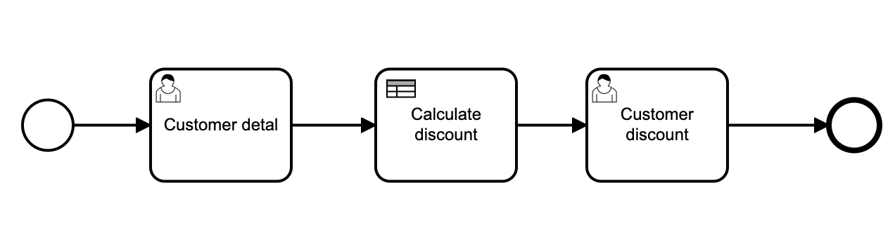
1. Process definition (BPMN)

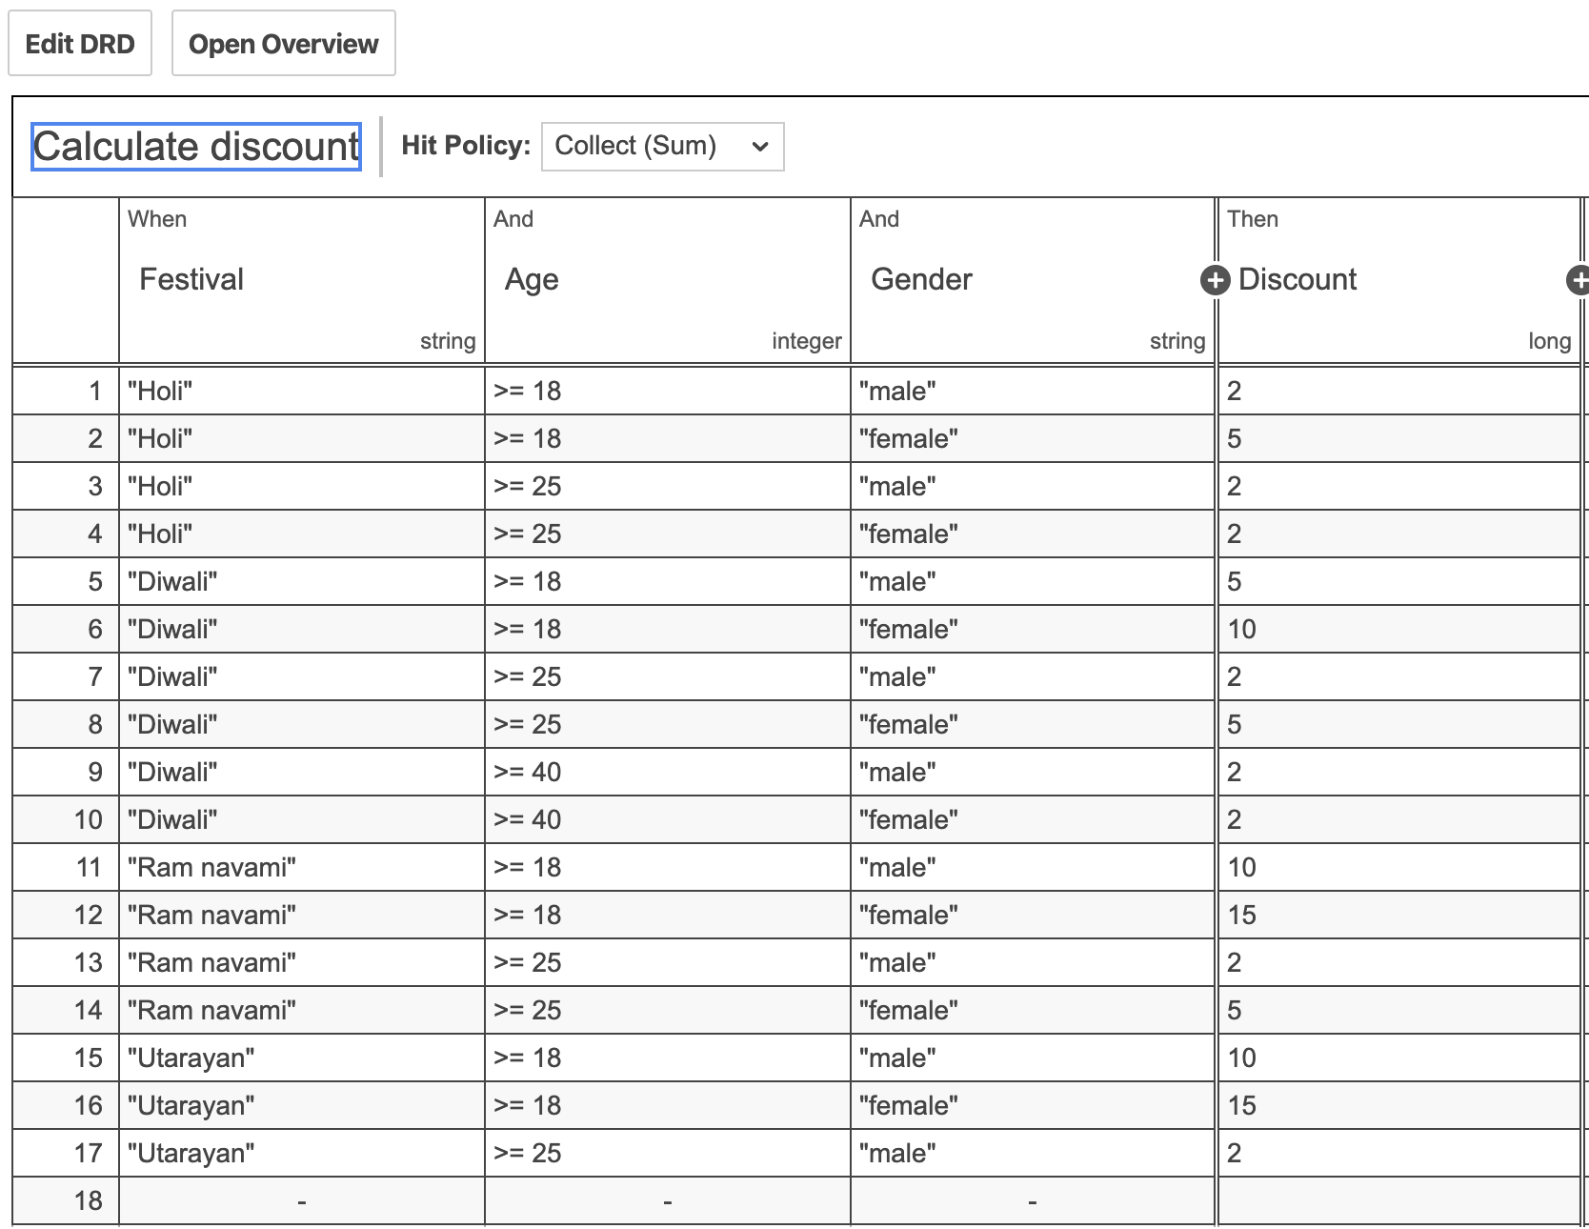
2. Decision table (DMN)

3. Process definition properties
Id: Process_HIT_policy_rule_collect
Name: Process HIT Policy Collect

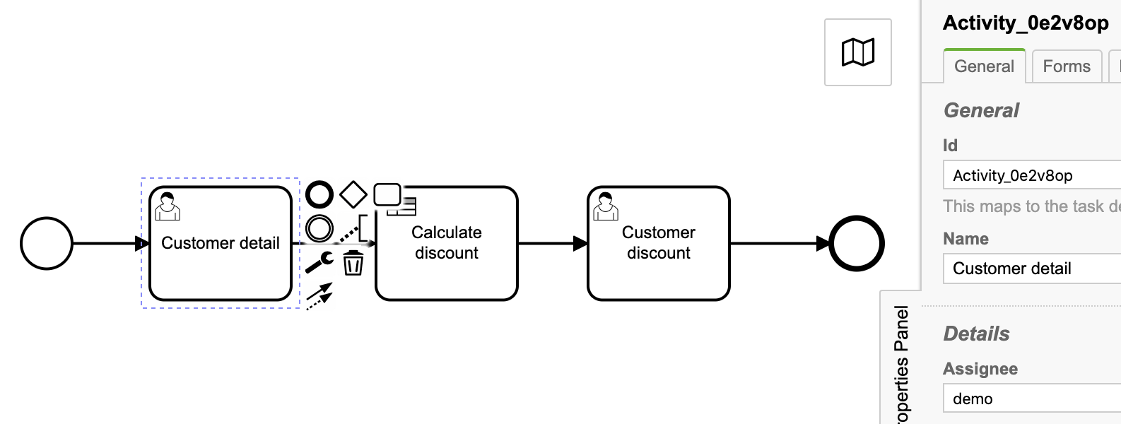
3.1. User task: Customer detail
Id: Activity_0e2v8op
Name: Customer detail
Assignee: demo

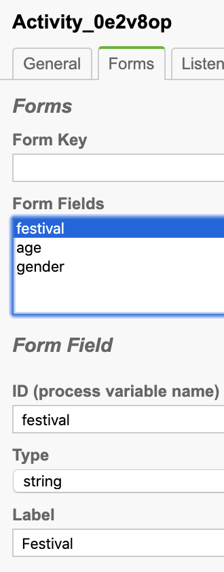
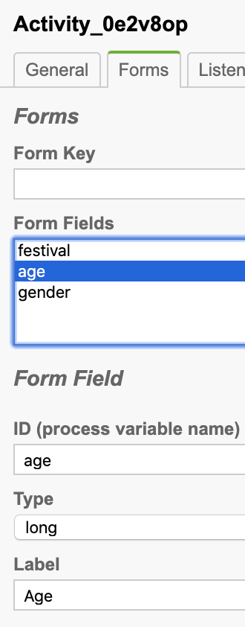
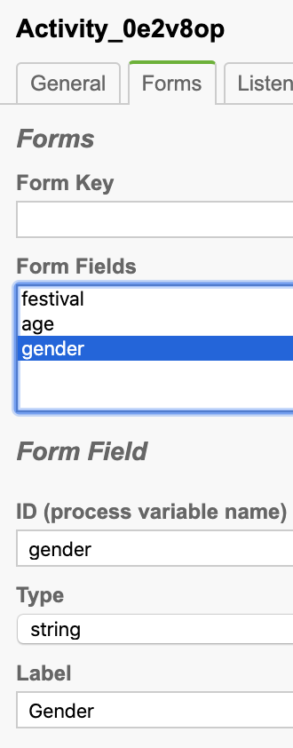
Task form

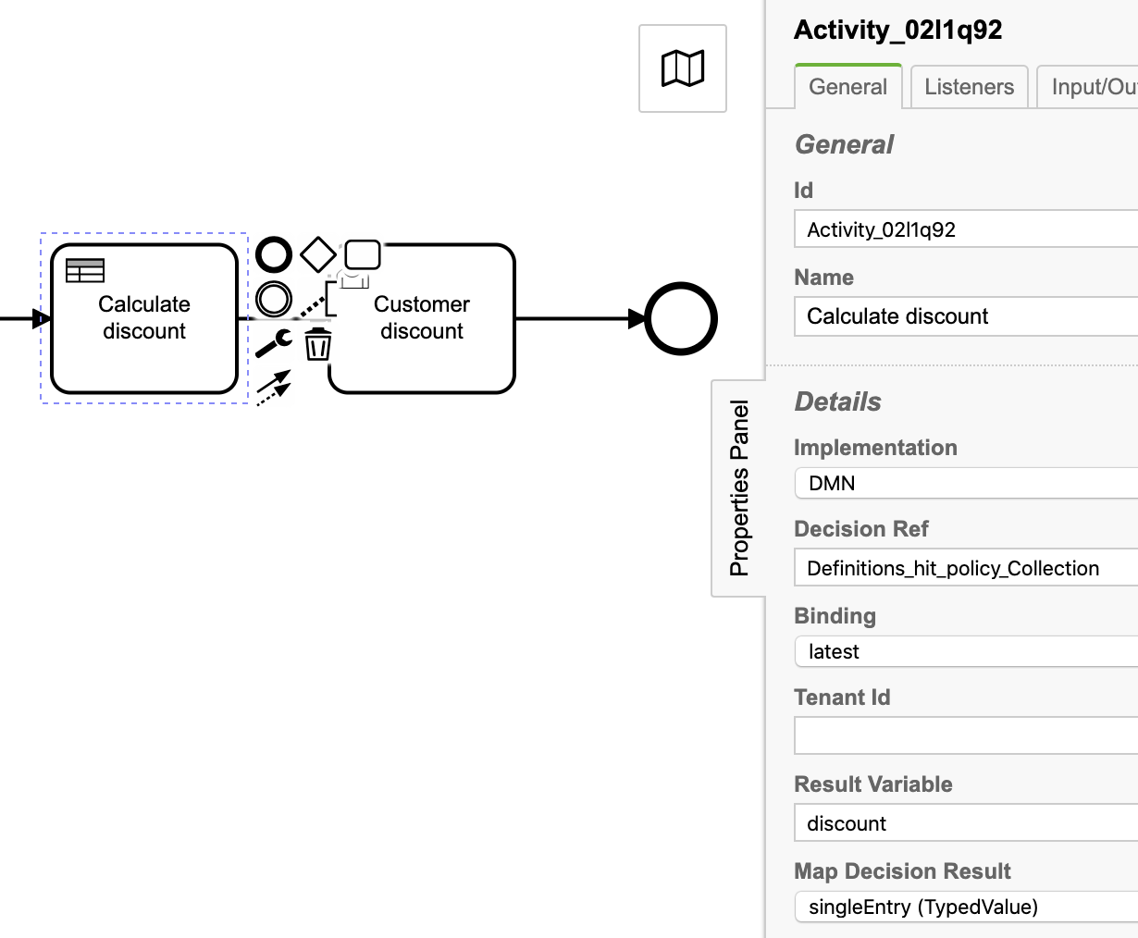
3.2. Business rule task: Calculate discount

Id: Activity_02l1q92
Name: Calculate discount
Implementation: DMN
Decision Ref: Definitions_hit_policy_Collection
Binding: latest
Result Variable: discount
Map Decision Result: singleEntry (TypedValue)

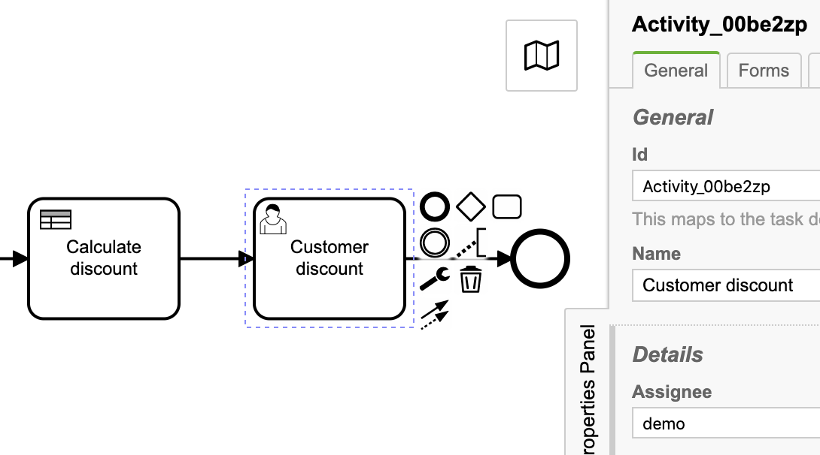
3.3. User task: Customer discount

Id: Activity_00be2zp
Name: Customer discount
Assignee: demo

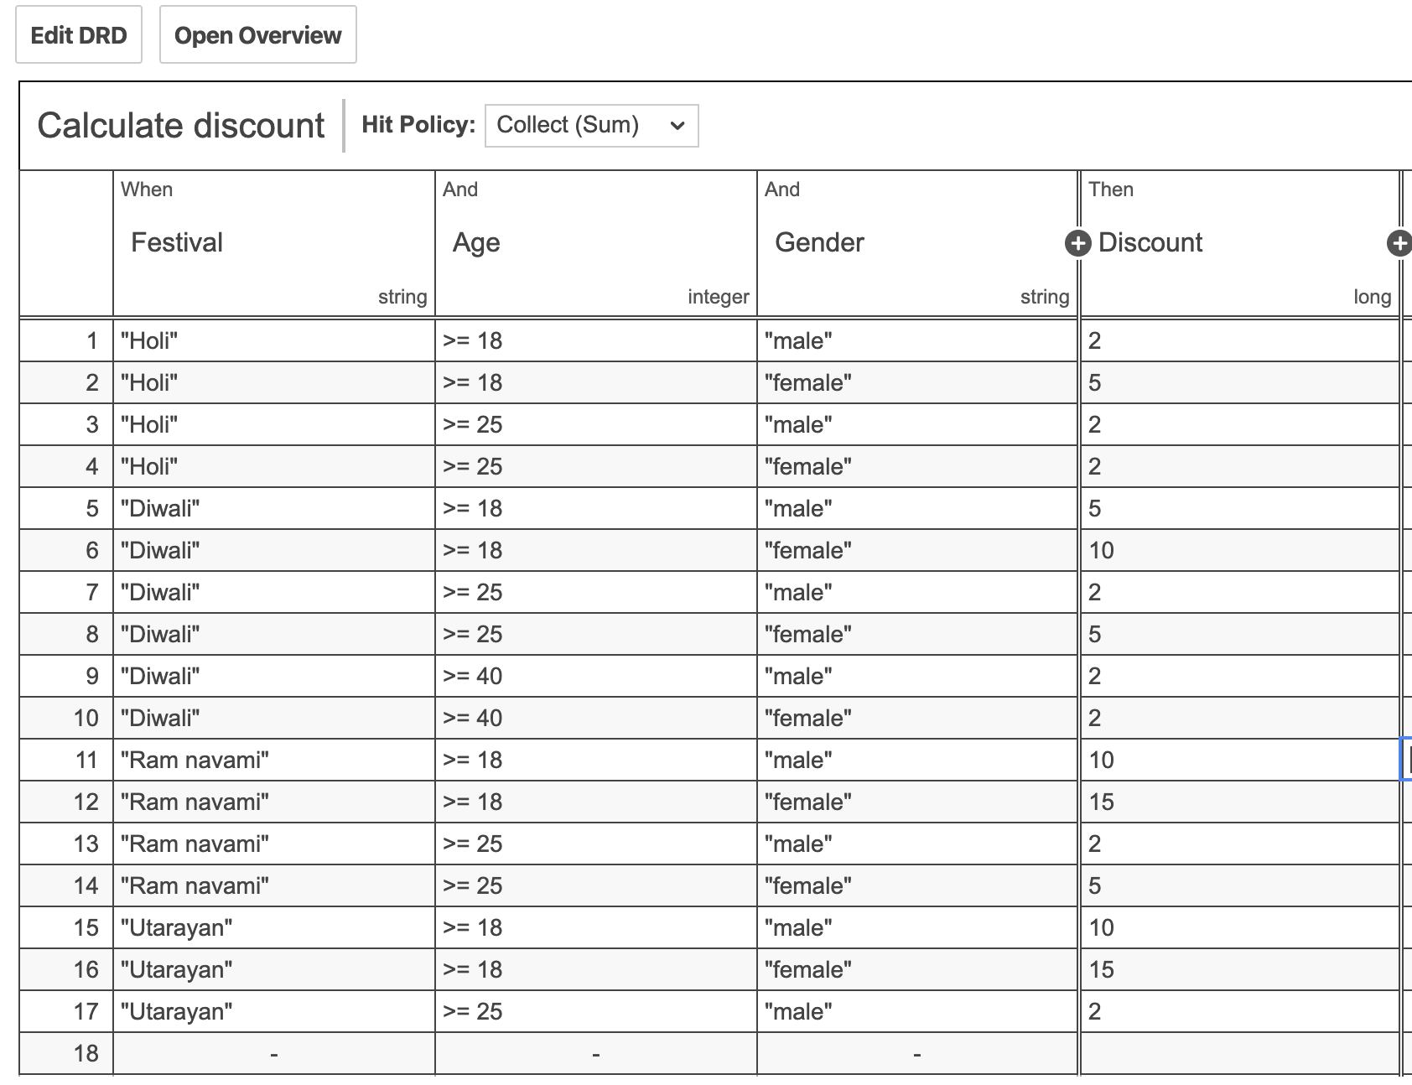
4. Decision table:

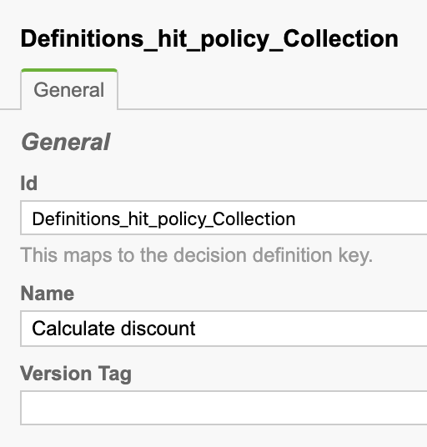
Properties:

Id: Definitions_hit_policy_Collection
Name: Calculate discount

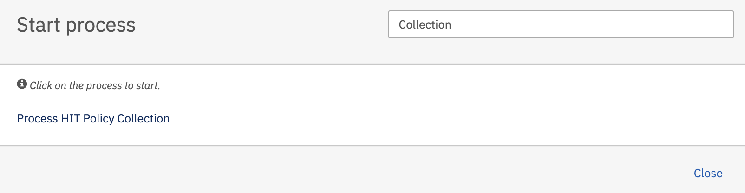
5. Deploy process definition and decision table.
Hit the Process HIT Policy Collection and press the Start button.

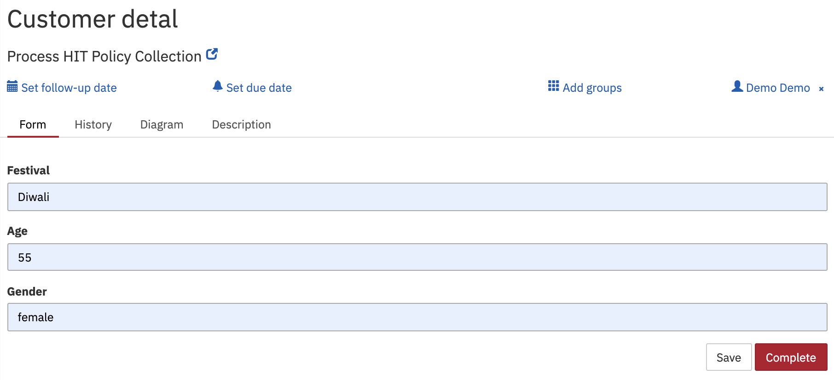
As per process definition, User task Customer detail will get created.
Fill-up the task and hit the Complete button, Business rule task get execute with provided inputs and generate the output with total discount and same can be viewed on user task Customer discount.

